HQIS

PERSONAL, SOCIAL, HEALTH EDUCATION POLICY

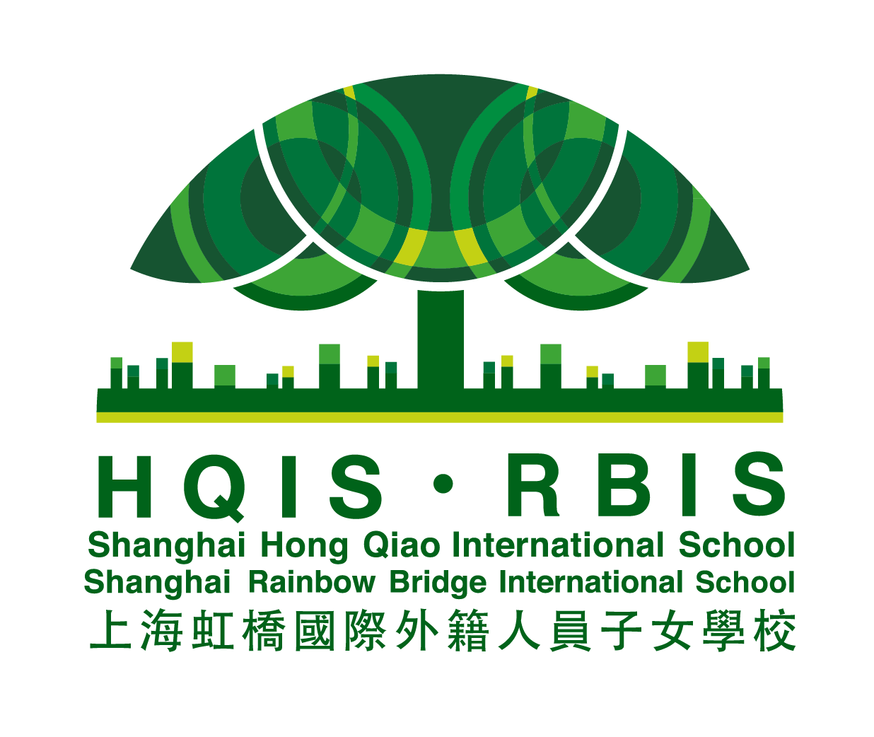

Effective Date Aug 2021
Governors’ Approval Aug 2021
Next Review Date Aug 2022

HQIS aims to promote the rights of the child as set by UNICEF’s Convention of Rights of the Child (CRC). As participants in this scheme we:

- Ensure that coverage of any relevant UNICEF Articles is undertaken.
- Listen to the views of the children in our school regarding equality, diversion and cohesion.
- This policy recognizes the child’s right to Article 24: All children have the
right to health care, and Article 16: All children have the right to privacy.

UNCRC Article 28: All children have the right to an education.
Policies and practice in Hongqiao International School respects children’s dignity.

Introduction

Health Education at HQIS encompasses all areas designed to promote children’s personal, social and health development. It gives children the knowledge, skills and understanding that they need to stay healthy and safe, develop worthwhile relationships, respect differences, develop independence and responsibility, make the most of their own abilities and those of others.

Aims

The interdependent aims, values and ethos of Hongqiao International School are supported by the provision of PSHE education. We want our children to develop self- awareness, positive self-esteem and confidence, enabling them to,

- stay as healthy as possible
- keep themselves and others safe
- have worthwhile and fulfilling relationships
- respect the differences between people
- develop independence and responsibility
- play an active role as members of a democratic society
- make the most of their own abilities and those of others
- behave in a socially and morally acceptable way including towards authority and each other
- to become involved in the life of their community
- to know about democracy and how to be active citizens
- to know about economic wellbeing.

We want our children to: -
- value the achievements they make, and the achievements of others
- make informed choices about dealing with risks and meeting challenges now and in the future.
- decide on values by which they want to live their lives.

Our school curriculum and ethos promotes spiritual, moral, social and cultural development and prepares all pupils for the opportunities and responsibilities within their lives.

Teaching PHSE
- value their achievements;
- deal with risk and meet the challenges of life now and in the future;
- identify their values and strive to live up to them;
- be effective and successful learners;
- make and sustain friendships;
- deal with and resolve conflict effectively and fairly;
- solve problems with others or by themselves;
- manage strong feelings such as frustration, anger and anxiety;
- be able to promote calm and optimistic states that promote the achievement of goals;
- recover from setbacks and persist in the face of difficulties;
- work and play cooperatively;
- compete fairly and win and lose with dignity and respect for competitors;
- Recognize and stand up for their rights and the rights of others;
- understand and value the differences and commonalities between people, respecting the right of others to have beliefs and values different from their own.
- have the ability to be reflective about their own beliefs, religious or otherwise, that inform their perspective on life and their interest in and respect for different people’s faiths, feelings and values
- have a sense of enjoyment and fascination in learning about themselves, others and the world around them
- use of imagination and creativity in their learning
- have a willingness to reflect on their experiences.
- have the ability to be reflective about their own beliefs, religious or otherwise, that inform their perspective on life and their interest in and respect for different people’s faiths,
The benefits of good PSHE teaching ensure that children:
The teaching of PSHE and Citizenship is not confined to a specific timetable session/lesson as it is delivered in a variety of forms at different times:

- discrete curriculum time
- teaching PSHE through and in other subjects/curriculum areas.
- circle time and other techniques and strategies.
- assemblies.
- through PSHE school events.

PSHE links together ideas form different subject areas especially ICT and the teaching of online safety and cyberbullying. Guidance issued from CCP’s Legislative Affairs Office of the State Council (LAOSC) for cyberbullying has been used to inform online safety policy and safeguarding. (see safeguarding and online safety policy for more details.)

A combination of these is needed in a whole school approach.

Links with Other Curriculum Areas
- English: Skills in enquiry and communication, stories that illustrate aspects of personal and social development;
- Mathematics: Aspects of financial capability; counting and sharing;
- Science: sex; health; safety and the environment;
- Design & Technology: Health and safety; healthy eating; realising that people have needs as they generate design ideas; use of technology;
- ICT: Communicating with others via e-mail; e-safety, cyberbullying, sexting finding information on the internet and checking its relevance;
- History: Use of sources; reasons for and results of historical events, situations and changes; diversity within societies studied; significant people, events, ideas and experiences of people from the past;
- Geography: Topical issues concerning environment, sustainable development, land use, study of pupils’ own locality and places in different parts of the world, including less economically developed countries;
- Art and Design: Reflecting on and responding to ideas and experiences communicated through works of art, craft and design from different times and cultures;
- Music: Making the most of abilities in playing or singing; issues of cultural diversity; their value and their expression;
- Physical Education: Teaching and learning about health and safety; development of personal and social skills through team and individual activities, games and sports;

PSHE and Citizenship Activities and School Events

At Hongqiao International Primary School we provide our pupils with many opportunities to plan and work together and thus develop relationships under different circumstances. Such opportunities include visits, special days and weeks, charity and fund raising events, links with the local community including career-related learning. Pupils can discover new qualities and characteristics through volunteering, participating and reflecting on new experiences.

Use of visitors
“Visitors should complement but never substitute or replace planned provision. It is the PSHE teacher’s responsibility to plan the curriculum and lessons.”
We believe that PSHE is most effectively taught by those who know our pupils well and are aware of their needs. We encourage visitors to our school who may enhance, but never replace, our planned provision. We will work closely with visitors to ensure that the needs of our pupils are met.
We will follow this Code of Practice when working with visitors:
- The care and management of pupils is the responsibility of the school at all times.
- In class teaching situations, visitors will not be asked to work alone with pupils, but will be supported by a member of staff.
- The school will know whether visitors are credentialed and arrangements will be made to
accompany them as appropriate.
- All visitors will be made aware of the content and principles of this Policy, prior to their visit.
- All lessons will be planned in direct liaison with the Class teacher, taking account of the age and
needs of the group and the context of the work within the SRE programme.
- Visitors will be reminded that, whilst contributing in a classroom setting, they must adhere to the same confidentiality code as staff members.
- Any resources which a visitor wishes to use or distribute will be discussed and agreed with the
Class Teacher beforehand.
- The contributions of visitors will be regularly monitored and evaluated.

Assessment
Assessment will follow the basis of a simple baseline assessment then a review of a previous group agreement or a new one agreed upon before the new topic for learning is introduced. After the teaching and learning on that particular topic has finished, children will be expected to show what they have learned through a simple summative assessment tool. The -I think/believe, I know, I can statements are good example.
We will involve children in the evaluation and development of their PHSE in ways appropriate to their age.

Monitoring and Evaluation
Monitoring is the responsibility of the homeroom teacher, Academic Dean and Head of Schools and teacher with responsibility for PHSE education.
The effectiveness of the PSHE programme will be evaluated by assessing children’s
learning and implementing change if required.

Child Protection / Confidentiality
Teachers need to be aware that effective PHSE education may lead to disclosure of a child protection issue. The staff member will inform the Homeroom Teacher /Designated Child Protection person in line with the Ministry of Education procedures for child protection.

This policy will be reviewed Annually

