Emergency Evacuation Procedure

2020-2021

HQIS Emergency Evacuation Procedure

SOUNDING THE ALARM

Alarm: In case of a real fire, the fire alarm will go off automatically on the effected floor.

Contact leadership and admissions immediately by calling admission (extension 8107). Admissions will make sure the school wide alarm is activated. If the fire is small, grab the nearest fire extinguisher and try to put it out.

Walkie-talkies: Sweepers, checkpoint personnel, staff in B1-B2 and leadership will have a walkie talkie which should always be on and set to channel 8. In the event of a reported fire leadership will communicate on channel 8 that there is a fire stating the following:
Attention. Please initiate Evacuation Procedures (in English and Chinese).

Contacting fire department: Guard Office will contact the fire department and request assistance.

Opening the gates: The security guards will open the Yili gate (which will be an exit gate for students) and open the Gu Yang gate for emergency vehicles.

EVACUATING STAFF AND STUDENTS

Emergency Exit Route: The map below shows which way each classroom exits the building towards checkpoint it (HQIS Yili Driveway Gate)

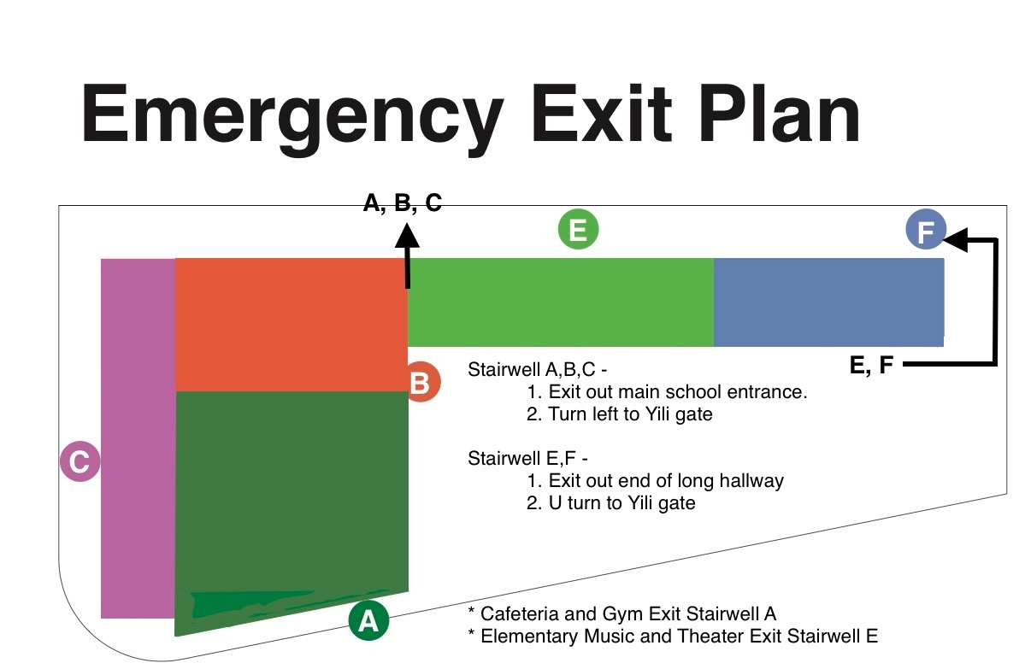
Check
point 1

Checkpoint Stations: Staff will evacuate to designated checkpoint area.

Checkpoint 1 –HQIS Yili Driveway Gate

Teacher duties:
- Have emergency folder (clipboard) with updated class list information with them
- Take attendance (ManageBac) and keep class quiet and under control
- Communicate class status to checkpoint coordinator using the red-green card system. Green = All students present and accounted for. Red = Student number incomplete or unaccounted for.
- Wait for verbal confirmation from the checkpoint coordinator to move to the park on Guyang Lu.

Coordinator Duties:
  - Assess the status of staff and students for each class
  - Check off classes that are all accounted for and direct them to Checkpoint 2.
  - RED CARD CLASSES – Write the name of missing/injured persons on the checkpoint form (see attached), send the class to YILI FUNGUI park (see attached map)
  - Communicate status to leadership

Checkpoint 2 – Yili – Fungui Park

YILI ROAD
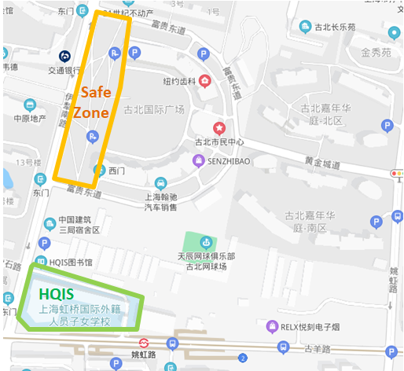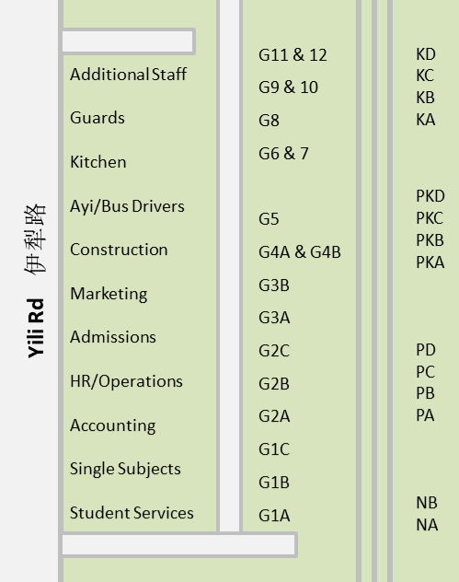

Teacher duties:
- Have emergency binder/clipboard with class list information with them
- Line students up in designated area
- Take attendance again and keep class quiet
- Communicate class status to checkpoint coordinator using the red-green card system

Coordinator Duties:
  - Assess the status of staff and students for each class
  - Check off classes that are all accounted. RED CARD CLASSES – Write the name of missing or injured persons on the checkpoint form (see attached)
  - Communicate the status on channel 1

Red-Green Card Accountability System

After taking attendance, teachers will indicate their class status by holding up a red or green card.

Red- Indicates that the teacher requires immediate attention.
- Student is missing
- Student is seriously injured

If a red card is indicated, the checkpoint coordinator will determine if the child is with another teacher. If the child is missing or injured, immediately communicate needs via walkie-talkie and building sweepers will re-check their assigned areas.

Green- Indicates all children are present and accounted for.
Checkpoint 2 - Once red cards are cleared, checkpoint coordinators will approach each teacher individually, check classes off and give verbal confirmation via walkie talkie.

Building Sweepers

After teachers have evacuated the building the Sweepers will check their designated area. They will:
- Listen for checkpoint coordinators information.
- Contact the other building sweepers via walkie-talkie once building and checkpoint areas are clear.
- Evacuate to checkpoint 2

Communication between checkpoint coordinators and building sweepers
- The Principal will do a name call check for building sweepers and checkpoint coordinators
- Coordinators and building sweepers should identify themselves by name and area of responsibility.
- The Principals will report any classes that are on field trips. Information will be communicated to checkpoint coordinators.
- Once the status of the checkpoint has been communicated, sweepers and checkpoint coordinators will move to checkpoint 2.

Emergency Medication and First Aid
The school nurse is responsible for evacuating campus with student’s emergency medication and first aid bag.

Non- Teaching Staff

All non-teaching staff (Kitchen, Ayi, maintenance, Admissions, guards, visitors, bus drivers, and accounting) will run through the same procedures as detailed above.

Student Contact Information

The school principals and admissions will keep a master copy of the student contact information in his or her attendance folders and are responsible for bringing it with them to checkpoint 2. If there are discrepancies between lists Admissions list will be utilized.

HQIS Emergency Evacuation Staff and Locations

Emergency evacuation staff members communicate information and direct activities during the evacuation period. Designated staff and the details of their responsibilities are described in the text below.

Checkpoint coordinators: Checkpoint coordinators will check the status of each class/Department at their designated checkpoint and communicate with building sweepers.

Checkpoint | Location | Departments | Responsible Staff
Checkpoint 1 | HQIS Front Gate (Yili Lu) | All | Roel Cruijff  Craig Su
Checkpoint 2 | Fugui Park | N-PS-PK-K  G1-G5  MS-HS  Non-teaching | JoAnna Marx & Gloria Li  Roel Cruijff & Barbara Ge  Amanda Pawlowski & Troy Hammond  Craig Su

Building Sweepers: Once classes have exited the building, sweepers will search designated areas for any children or staff and will maintain communication with checkpoint coordinators.

 | Location | Responsible Staff
Area # 1 | 4th Floor (L402-L421) | Anique Kruger | Audra Gu
Area # 2 | 3rd Floor atrium (L301-L320) | Marx Zhang | Ally Yan
Area # 3 | 3rd Floor Long Hallway (L321-L328) | Shawn Cullen | Jessica Yu
Area # 4 | 2 nd Floor Atrium (L201-L219) | Nonna Delingon | Sissi Zhu
Area # 5 | 2nd Floor Long Hallway (L220-L227) | Scott Aylwin | Hannah Chen
Area # 6 | 1st floor Atrium (L102-L118) | Darcy Da | Alex Hu
Area # 7 | 1st floor long hallway (L119-L127) | Lydia Sun | Michael Guolo
Area # 8 | B1 | Shi Rui
Area # 9 | B2 | Jim Cabungcal

Emergency Vehicle Director: The HQIS security guard will direct emergency vehicles inside of the school campus and communicate activity with building sweepers and checkpoint coordinators. The security guard on duty is responsible for this position.

HQIS Emergency Evacuation Procedure Teacher Responsibility

If you are the first to encounter a fire in the building

- The alarm should go off automatically on the affected floor.
- Contact admissions immediately (8017)
- If the fire is small, try to extinguish it with a fire extinguisher.
- Proceed with emergency evacuation procedure.

Emergency evacuation procedure:

- Ensure you have your emergency folder
- Line up students
- Conduct a head count/take attendance
- Check the room for students
- Turn lights off and lock doors
- Exit via your nearest evacuation route (as shown on your map) with Classroom Teacher at the front and Chinese Teacher at the rear (or as appropriate)
- Go through exit procedure at checkpoint 1(page 2)
- Walk to the park on Yili and Fungui.
- Act as crossing guards as you cross the street
- Line students up in designated area
- Take attendance
- Hold up your green card if all children are present and accounted for or the red card if someone is missing or there is a problem

Checkpoint Coordinators and Locations: Checkpoint coordinators will meet staff and students in the designated areas.

