HQIS

CHILD PROTECTION
POLICY AND GUIDELINES
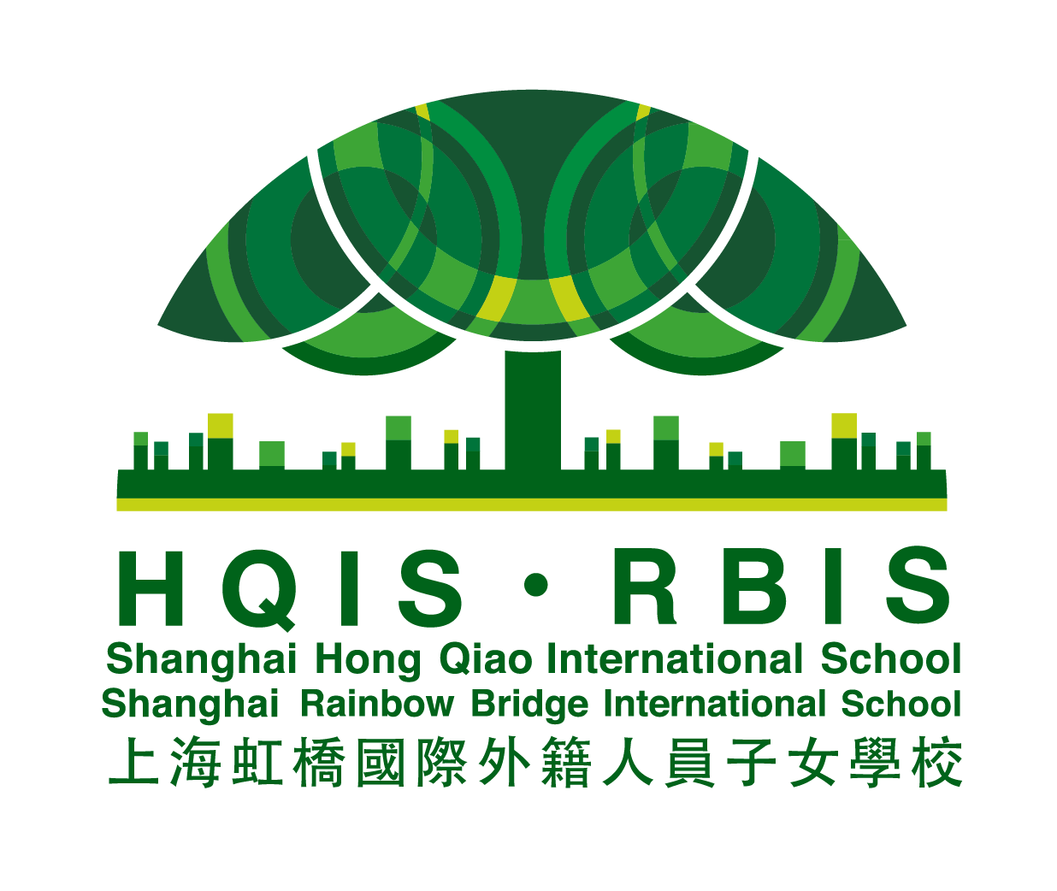

Effective Date Aug 2021
Governors’ Approval Aug 2021
Next Review Date Aug 2022
CONTENTS
- Key contacts p.2
- Policy statement and principles p.4
- Safeguarding legislation and guidance p.6
- Child protection procedures p.11
- Roles & Responsibilities p.20
- Good practice guidelines and staff code of conduct p.23
- Abuse of trust p.24
- Children who may be particularly vulnerable p.24
- Support for those involved in a child protection issue p.24
- Complaints procedure p.25
- If a member of staff has concerns about a colleague p.25
- Allegations against staff p.25
- Staff training p.26
- Safer recruitment p.26
- Third Party Use and offsite arrangements p.27
- Photography and images p.28
- E-safety p.29

Appendix
Child protection reporting flow chart p.31

1. Key Contacts
Designated Safeguarding Lead (DSL) | Child Protection Officers  Lower School - JoAnna Marx  Upper School - Tomasz Kalaczek
Deputy Designated Safeguarding Leads | Gloria Li (Early Years)  Barbara Ge (Elementary)  Anique Kruger (Upper School)
Nominated Board member | Child Protection Officer / Chair of Board (Barbara Ge)
Associate Principals  Upper, School, Lower School, Early Years | Roel Cruijff, JoAnna Marx, Alex Thrower
External Contacts
International Child Protection Advisers (ICPA) | Tim Gerrish  m: +44 (0) 7836697397 e: tim@icpa.co.uk skype: tim.gerrish100 web: www.icpa.co.uk
Council of International School: Safeguarding | CIS  Schipholweg 113  2316 XC Leiden  The Netherlands  Phone: +31 (0) 71 524 3300  Email: info@cois.org
Police: Shanghai | Contact through Craig Su (Director of Operations)  Email: craig.su@hqis.org
Embassies in Shanghai | Depending on the student’snationality the embassy should be contacted as appropriate via websites
Save the Children: Beijing, China | General Inquiries:  public@chinadevelopmentbrief.cn  Gabriel Corsetti, Deputy Director of the Media and Communications Department:  gabriel.corsetti@cdb.org.cn  Luo Bing, Senior Media Officer,  luo.bing@cdb.org.cn
UNHCR Beijing | China Office, No 2 Liang Ma He Nan Lu,  100600 Beijing  T: 86 1065326806  E chibe@unhcr.org

2. POLICY STATEMENT AND PRINCIPLES

Key Points

- This policy applies to all students in the School policy but legally as some students will be 18 years and over they may be treated differently outside of school. Students under the age of 18 will be regarded as children in this policy.
- All staff have a responsibility for implementing this policy;
- Any concerns regarding safeguarding and/or child protection must be reported immediately to the Designated Safeguarding Lead (DSL) or Deputy Designated Safeguarding Lead (DDSL);
- If a crime has been committed, it should be reported to the DSL immediately who reports to the police;
- All staff must read this policy and this is a contractual requirement;
- All staff must be able to identify the DSL and DDSLs.
- All safeguarding and child protection concerns are confidential;
- The DSL or DDSL must report concerns according to the requirements of the P.R.C.
- Allegations of abuse in relation to adults must be dealt with in line with the relevant policy.
Introduction
HQIS is committed to safeguarding and promoting the welfare of students attending the school and expects all employees and visitors to share this commitment.
This policy applies to staff, volunteers and contractors working with pupils on school premises or away from the school on trips or off-campus activity.
This policy therefore complements and supports our other policies. When undertaking development or planning of any kind, the School will consider safeguarding aspects. Our safeguarding requirements are formulated to meet the standards set within the best international schools in Asia.

The School’s core safeguarding principles are:
- The School recognises the importance of safeguarding and promoting the welfare of children enrolled at HQIS;
- The School ensures that safeguarding children is everyone’s responsibility. Everyone who comes into contact with children and our families hasa role to play in keeping children safe;
- Listening to children and others within our school community is vital to safeguarding the individual child
- HQIS is committed to the rights of concerned individuals to speak out if they ‘see something, hear something, sense something ‘
- The slightest concern needs to be raised early so it can be investigated quickly and any further harm avoided
- If a child needs help then our ‘speak up culture’ needs collective adoption.
- Colleagues in the school community should recognise that there are risks in any organization and good policy is not, in itself a mitigating factor.
- Safer children make more successful learners and this is key to our mission.
- Adults in schools also need to be aware that children may be at risk off campus.
- Policy development and review involves the whole community. Updates will be widely communicated to all.
- Policies will be reviewed at least annually unless an incident or new legislation or guidance suggests the need for an interim review.
- Children themsleves need to be aware that there is a policy in place and they can speak in confidence to specific individiuals who will hear their concerns.

Terminology Key
Safeguarding and promoting the welfare of children refers to the process of protecting children from maltreatment, preventing the impairment of health or development, ensuring that children grow up in circumstances consistent with the provision of safe and effective care and taking action to enable all children to have the best outcomes.
Child protection refers to the processes undertaken to protect children who have been identified as suffering, or being at risk of suffering significant harm.
Members of staff refers to all those working for or on behalf of the school, full time or part time, including contracted staff such as cleaners and kitchen staff, temporary or permanent, in either a paid or voluntary capacity.
Child includes everyone under the age of 18 and in our care. However our duty to promote the welfare and health and safety applies to all our students in our care whether they are under or over the age of 18.
Parent refers to birth parents and other adults who are in a parenting role, for example step-parents, guardians, foster carers, adoptive parents and grand-parents.

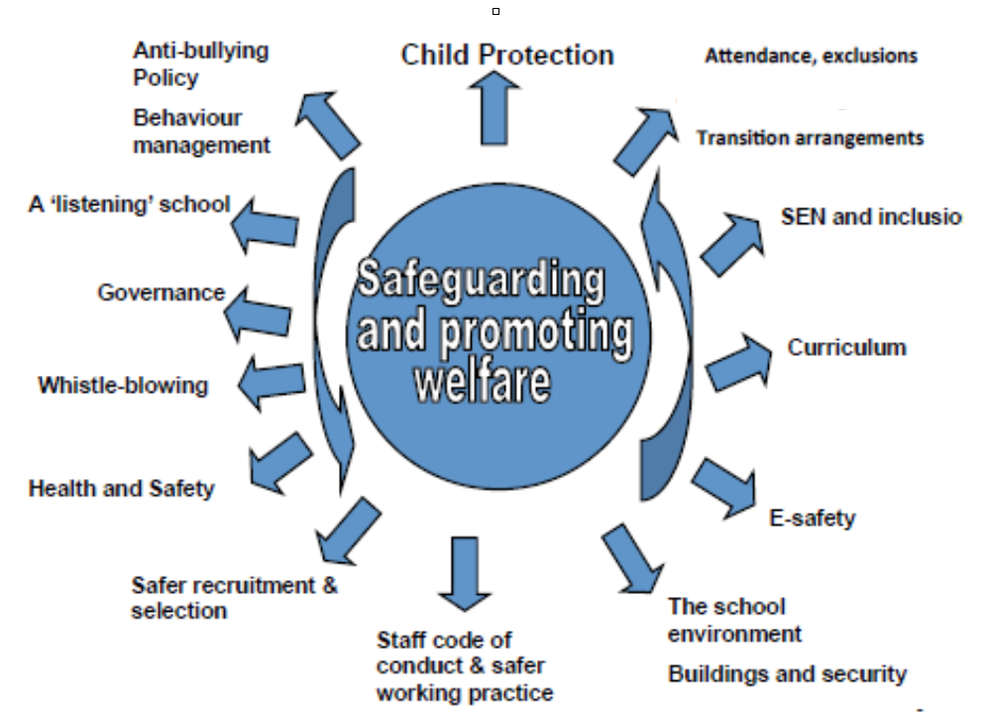
3. Safeguarding at HQIS
This includes
- Ensuring pupil health and safety;
- Referring concerns or allegations about a child to the appropriate bodies promptly;
- bullying;
- all forms of abuse;
- harassment and discrimination;
- use of physical intervention;
- meeting the needs of pupils with medical conditions;
- providing first aid;
- drug and substance misuse;
- educational visits;
- intimate care;
- internet safety;
- issues which may be specific to a local area or population, for example gang activity; and
- school security.
Child Protection Statement
HQIS fully recognizes its legal responsibilities in the P.R.C. as well as seeking to fully meet international standards of safeguarding and maintaining welfare of all children. We endeavor to provide a safe and welcoming environment where children are respected and valued. We are alert to the signs of abuse and neglect and follow our procedures to ensure our students receive effective support, protection, and justice throughout their school years at HQIS.
Policy Principles
HQIS’s principles are aligned with those of the United Nations Convention on the Rights of the child (UNCRC). Central to this is the acknowledgment that every child has basic fundamental rights. These include the right to:

• life, survival and development
• protection from violence, abuse or neglect
• an education that enables each child to fulfill his or her potential
• be raised by, or have a relationship with parents or guardians
• express their opinions and be listened to.

Therefore the welfare of the child is paramount;
- All children, regardless of age, gender, ability, culture, race, language, religion or sexual identity, have equal rights to protection;
- All members of staff have equal responsibility to act on any suspicion or disclosure that may suggest a child is at risk of harm;
- Children, and staff involved in child protection issues, will receive appropriate support inside the School.
Policy Aims
To provide all staff with the necessary information to enable them to meet their child protection responsibilities;
To ensure consistent good practice;
To demonstrate the School’s commitment with regard to child protection to students, parents and other partners;
To contribute to the School’s portfolio of safeguarding policies.

The School’s Commitment
There are seven main elements to our policy:
- Establishing a safe environment in which students can learn and develop; include in the curriculum activities and opportunities, which equip children with the skills needed to stay safe from abuse and will develop resilience and realistic attitudes to the responsibilities of adult life;

- Ensuring the governance of safeguarding and promotion of welfare is fully embedded within the school;

- Raising awareness of child protection issues and ensuring staff, volunteers and contractors working at the school are fully aware of presenting issues and how to act in the event of concerns being raised;

- Ensuring staff recruitment practice is safe and fully accords with the requirements of Keeping Children Safe in Education and CIS Standards so the school operate safe recruitment procedures and makes sure that all appropriate checks are carried out on new staff and volunteers who will work with the children;

- Supporting pupils who are in need of protection or require additional help to achieve good outcomes.

- Listening to the children in our care and ensuring that children know that there are adults in the School whom they can approach if they are worried or are in difficulty, as the ethos is one where children feel secure and are encouraged to talk, and are listened to;

- Creating an open-culture where staff feel confident to speak-up whenever they have concerns about a child or a particular adult, and are aware of how and when to act on concerns that they have and work in a safe and appropriate manner at all times.

Confidentiality
Shanghai Rainbow Bridge International School recognizes that all matters relating tochild protection are highly confidential. The Head Master or the Designated Safeguarding Lead will share that information on a ‘need to know, what, and when’ basis. Concerns about individuals should never be discussed elsewhere, inside or outside the School unless in confidential meetings for that purpose.
3. SAFEGUARDING LEGISLATION AND GUIDANCE:
The child protection policy and accompanying procedures are based on local, national and international law, including:
Minors Protection Law of China (2020)
There are 132 articles in the Law on the Protection of Minors, which are divided into nine
chapters: general provisions, family protection, school protection, social protection, network protection, government protection, judicial protection, legal responsibility and supplementary provisions.

Some noteworthy points are as follows:
1. Social and network protection
2. Prevention and handling of school bullying (including online)
3. Prevention and handling of child sexual assault
4. Family protection

The official Chinese version of the policy: http://lawdb.cncourt.org/show.php?fid=152560

Note: At the time of this policy review, there was no official English version of the new Minors Protection Law of China. A summary of the law in English can be found at the following link:
https://www.chinajusticeobserver.com/law/x/minors-protection-law-20201017

Anti-domestic Violence Law of the People’s Republic of China, 2015:
In 2015, a new law was passed that protects foreigners and Chinese citizens within China’s borders from domestic violence. Two articles of this law have specific implications for children and schools:

Article 14: Schools, kindergartens, medical institutions, residents' committees, villagers'
committees, social service agencies, aid management agencies, welfare agencies and their
staff members shall promptly report cases to public security organs if they find, during the
course of their work, that persons with no civil capacity or persons with limited civil capacity have suffered or are suspected of suffering domestic violence. Public security organs shall keep confidential the identity of case reporters.

Article 35: Where a school, kindergarten, medical institution, residents' committee, villagers' committee, social service agency, aid management agency, welfare agency and its staff members fail to report a case to a public security organ in accordance with Article 14 herein, resulting in serious consequences, the person directly in charge and other persons subject to direct liabilities shall be given disciplinary sanctions pursuant to the law by the relevant superior competent department or their own employer.

Standing Committee of the National People’s Congress, (2015) Anti-domestic Violence Law of the People’s Republic of China. Order No.37 of the President, PRC.

UN Convention on the Rights of The Child:
This policy is also based on the United Nations Convention on the Rights of the Child of which China is a signatory. The two key articles are:

Article 19 – Protection from abuse and neglect
1. States Parties shall take all appropriate legislative, administrative, social and educational measures to protect the child from all forms of physical or mental violence, injury or abuse, neglect or negligent treatment, maltreatment or exploitation, including sexual abuse, while in the care of parent(s), legal guardian(s) or any other person who has the care of the child.
2. Such protective measures should, as appropriate, include effective procedures for the establishment of social programmers to provide necessary support for the child and for those who have the care of the child, as well as for other forms of prevention and for identification, reporting, referral, investigation, treatment and follow-up of instances of child maltreatment described heretofore, and, as appropriate, for judicial involvement.

Article 34 – Protection from sexual exploitation
States Parties undertake to protect the child from all forms of sexual exploitation and sexual abuse. For these purposes, states parties shall in particular take all appropriate national, bilateral and multilateral measures to prevent:
(a) The inducement or coercion of a child to engage in any unlawful sexual activity;
(b) The exploitative use of children in prostitution or other unlawful sexual practices;
(c) The exploitative use of children in pornographic performances and materials.

United Nations International Children’s Emergency Fund (UNICEF), (1989) The United Nations Convention on the Rights of the Child. London: Author

This policy has been reviewed and commented on by FuJae Partners, a PRC law firm with
Chinese and International legal experiences.

4. CHILD PROTECTION PROCEDURES
Providing early help is more effective in promoting the welfare of children than reacting later. We are aware that all our members of staff have a responsibility in school to identify the symptoms and triggers of abuse and neglect, to share information and work together to provide children and young people with the help they need.

KCSIE states that: ‘Where a child is suffering significant harm, or is likely to do so, action should be taken to protect that child. Action should also be taken to promote the welfare of a child in need of additional support, even if they are not suffering harm or are at immediate risk.’
Sometimes a single traumatic event may constitute significant harm, such as poisoning or a violent assault. However, more often it is a compilation of significant events, both acute and long standing, which can change or damage a child’s physical and psychological development. Some children have a family and/or social circumstances where their health and development are neglected. For them it is the corrosiveness of long-term neglect, emotional, physical or sexual abuse that causes impairment to the extent of constituting significant harm.
Recognizing abuse
To ensure that our children are protected from harm, we need to understand what types of behavior constitute abuse and neglect.
Abuse and neglect are forms of maltreatment. Somebody may abuse or neglect a child by inflicting harm, for example by hitting them, or by failing to act to prevent harm (for example by leaving a small child home alone, or leaving knives or matches within reach of an unattended toddler). Abuse may be committed by adult men or women and by other children and young people. Children may be abused in a family or in an institutional or community setting by those known to them or, more rarely, by others (e.g. via the internet). Internet abuse is a growing concern and schools should be vigilant to this.
There are four categories of abuse: physical abuse, emotional abuse, sexual abuse and neglect. All staff should be aware that abuse, or safeguarding issues are rarely standalone events that can be covered by one definition or label. In most cases multiple issues will overlap with one another.
Physical abuse
Physical abuse is a form of abuse which may involve hitting, shaking, throwing, poisoning, burning or scalding, drowning, suffocating or otherwise causing physical harm to achild. Physical harm may also be caused when a parent or carer fabricates the symptoms of, or deliberately induces, illness in a child.

Emotional abuse
Emotional abuse is the persistent emotional maltreatment of a child such as to cause severe and persistent adverse effects on the child’s psychological state and emotional development. It may involve conveying to a child that they are worthless or unloved, inadequate, or valued only in so far as they meet the needs of another person. It may include not giving the child opportunities to express their views, deliberately silencing them or ‘making fun’ of what they say or how they communicate. It may feature age or developmentally inappropriate expectations being imposed on children. These may include interactions that are beyond a child’s developmental capability, as well as overprotection and limitation of exploration and learning, or preventing the child participating in normal social interaction. It may involve seeing or hearing the ill treatment of another. It may involve serious bullying (including cyber-bullying), causing children frequently to feel frightened or in danger, or the exploitation or corruption of children. Some level of emotional abuse is involved in all types of maltreatment of a child, although it may occur alone.

Sexual abuse
Sexual abuse involves forcing or enticing a child or young person to take part in sexual activities, not necessarily involving a high level of violence, whether or not the child is aware of what is happening. The activities may involve physical contact, including assault by penetration (for example, rape or oral sex) or non-penetrative acts such as masturbation, kissing, rubbing and touching outside of clothing. They may also include non-contact activities, such as involving children in looking at, or in the production of, sexual images, watching sexual activities, encouraging children to behave in sexually inappropriate ways, or grooming a child in preparation for abuse (including via the internet). Sexual abuse is not solely perpetrated by adult males. Women can also commit acts of sexual abuse, as can other children.
Neglect
Neglect is the persistent failure to meet a child’s basic physical and/or psychological needs, likely to result in the serious impairment of the child’s health or development. Neglect may occur during pregnancy as a result of maternal substance abuse. Once a child is born, neglect may involve a parent or carer failing to:
- Provide adequate food, clothing and shelter (including exclusion from home or abandonment);
- protect a child from physical and emotional harm or danger;
- ensure adequate supervision (including the use of inadequate care-givers); or
- ensure access to appropriate medical care or treatment.
This form of abuse may also include neglect of, or unresponsiveness to, a child’s basic emotional needs.
The above categories are identified by the NSPCC, and definitions have been taken from Working Together to Safeguard Children (DfE July 2015 and 2 an KCSIE (DfE May 2016)
Specific safeguarding issues
All staff should have an awareness of safeguarding issues-some of which are listed below:
- bullying including cyber bullying
- (see below)
- child sexual exploitation (CSE)—and Annex A
- domestic violence
- drugs
- fabricated or induced illness
- faith abuse
- female genital mutilation (FGM)—and Annex A
- forced marriage-and Annex A
- gangs and youth violence
- gender based violence/violence against women and girls(VAWG)
- hate
- mental health
- private fostering
- preventing radicalisation—and Annex A
- relationship abuse
- sexting
- trafficking

Annex A of KCSIE May 2016 contains important additional information about specific forms of abuse and safeguarding issues. School leaders and those staff that work directly with children should read the annex.

Staff should be aware that behaviours linked to the likes of drug taking, alcohol abuse, truanting and sexting put children in danger.

All staff should be aware safeguarding issues can manifest themselves via peer on peer abuse. This is most likely to include, but not limited to: bullying (including cyber bullying), gender based violence/sexual assaults and sexting.

Staff should be clear as to Shanghai Rainbow Bridge International School’s policy and procedures with regards to peer on peer abuse.

Bullying
While bullying between children is not a separate category of abuse and neglect, it is a very serious issue that can cause considerable anxiety and distress. At its most serious level, bullying can have a disastrous effect on a child’s wellbeing and in very rare cases has been a feature in the suicide of some young people. All incidences of bullying, including cyber-bullying and prejudice-based bullying should be reported and will be managed through our anti-bullying procedures. Deans will keep records of bullying-type behaviour, which should be submitted termly to the DSL. The School’s Anti-Bullying Policy is part of our Conduct Management section of the Student Handbook and it is annually reviewed and published to all children at the start of each academic year.
The subject of bullying is addressed at regular intervals via the school’s policies and curriculum for Personal Development. If the bullying is particularly serious, or the anti-bullying procedures are deemed to be ineffective, the Head of School and the DSL will consider implementing child protection procedures.
Indicators of abuse
Physical signs define some types of abuse, for example, bruising, bleeding or broken bones resulting from physical or sexual abuse, or injuries sustained while a child has been inadequately supervised. The identification of physical signs is complicated, as children may go to great lengths to hide injuries, often because they are ashamed or embarrassed, or their abuser has threatened further violence or trauma if they ‘tell’. It is also quite difficult for anyone without medical training to categories injuries into accidental or deliberate with any degree of certainty. For these reasons, it is vital that members of staff are also aware of the range of behavioural indicators of abuse and report any concerns to the DSL.

A child who is being abused or neglected may:

- have bruises, bleeding, burns, fractures or other injuries;
- show signs of pain or discomfort;
- keep arms and legs covered, even in warm weather;
- be concerned about changing for PE or swimming;
- look unkempt and uncared for;
- change their eating habits;
- have difficulty in making or sustaining friendships;
- appear fearful;
- be reckless with regard to their own or other’s safety;
- self-harm;
- show signs of not wanting to go home;
- display a change in behaviour – from quiet to aggressive, or happy-go-lucky to withdrawn;
- challenge authority;
- become disinterested in their school work;
- be constantly tired or preoccupied;
- be wary of physical contact;
- be involved in, or particularly knowledgeable about drugs or alcohol; or
- display sexual knowledge or behaviour beyond that normally expected for their age.

Individual indicators will rarely, in isolation, provide conclusive evidence of abuse. They should be viewed as part of a jigsaw, and each small piece of information will help the DSL to decide how to proceed. It is therefore essential that staff report their concerns. Staff do not need ‘absolute proof’ that a child is at risk but should act on any hunches or worries in the knowledge that they will be supported in their safeguarding role. Reports made in good faith will always be dealt with in confidence and, regardless of outcome, the staff member who reports a concern will be supported in this process.
Impact of abuse
The impact of child abuse should not be underestimated. Many children do recover well and go on to lead healthy, happy and productive lives, although most adult survivors agree that the emotional scars remain, however well buried. For some children, full recovery is beyond their reach, and the rest of their childhood and their adulthood may be characterized by anxiety or depression, self-harm, eating disorders, alcohol and substance misuse, unequal and destructive relationships and long-term medical or psychiatric difficulties.

Taking action
Any child, in any family, in any school could become a victim of abuse. Staff should always maintain an attitude of “it could happen here”. Key points for staff to remember for taking action are:
- in an emergency take the action necessary to immediately help the child,
- report your concern to the DSL as soon as possible;
- do not start your own investigation;
- share information on a need-to-know basis only – do not discuss the issue with colleagues, friends or family;
- complete a record of concern; and
- seek support for yourself, if you are distressed.
If you are concerned about a child’s welfare
There will be occasions when a member of staff may suspect that a child may be at risk, but have no ‘real’ evidence. The child’s behavior may have changed, his actions may reveal confusion or distress, or physical but inconclusive signs may have been noticed. In these circumstances, the member of staff must try to give the child an opportunity to talk. The signs they have noticed may be due to a variety of factors, for example, a parent has moved out, a close friend or relative has died, a grandparent is very ill. Staff are fully entitiles to ask the child if they need help or support in any way.
Staff should report their concerns to the child’s Dean. If the child does begin to reveal that they are being harmed, staff should follow the advice below. Following an initial conversation with the child, if the member of staff remains concerned, they should discuss their concerns with the DSL.
If a child discloses to you
It takes a lot of courage for a child to disclose that they are being abused. They may feel ashamed, particularly if the abuse is sexual; their abuser may have threatened what will happen if they tell; they may have lost all trust in adults; or they may believe, or have been told, that the abuse is their own fault.
If a child talks to a member of staff about any risks to their safety or wellbeing, the staff member will need to let the child know that they must pass the information on – staff are not allowed to keep secrets and must never promise to do so. The point at which they tell the child this is a matter for professional judgement. If they jump in immediately, the student may think that they do not want to listen. If left until the very end of the conversation, the child may feel that he has been misled into revealing more than he would have otherwise.
During their conversations with the children members of staff will:
- allow them to speak freely;
- remain calm and not overreact – the child may stop talking if they feel they are upsetting their listener;
- give reassuring nods or words of comfort – ‘I’m so sorry this has happened’, ‘I want to help’, ‘This isn’t your fault’, ‘You are doing the right thing in talking to me’;
- not be afraid of silences – members of staff must remember how hard this must be for the child;
- under no circumstances ask investigative questions – such as how many times this has happened, whether it happens to siblings too, or what does the student’s parent(s) think about all this;
- at an appropriate time tell the child that in order to help them, the member of staff must pass the information on;
- not automatically to offer any physical touch as comfort. It may be anything but comforting to a child who has been abused;
- avoid admonishing the child for not disclosing earlier. Saying things such as ‘I do wish you had told me about this when it started’ or ‘I can’t believe what I’m hearing’ may be the staff member’s way of being supportive but could be interpreted by the child to mean that they have done something wrong;
- tell the child what will happen next. The child may agree to go to see the DSL or his Dean. Otherwise let the child know that someone will come to see them before the end of the day;
- report verbally to the DSL, even if the child has promised to do this by themselves;
- write up their conversation as soon as possible on the record of concern form and hand it to the DSL; and
- seek support if they feel distressed by what they have heard from the child.
Notifying parents
The School will normally seek to discuss any concerns about a child with their parents. This must be handled sensitively. The DSL will make contact with the parent in the event of a concern, suspicion or disclosure unless the School believes that notifying parents could increase the risk to the student or exacerbate the problem. Advice will first be sought from other agencies where possible.
Children with sexually harmful behaviour
It is important to recognize the potential for abuse by peers. With regards to student-on-student abuse staff will refer such abuse to the DSL who will consult with external where there is a risk of significant harm. Allegations of student-on-student abuse will involve parents being contacted.
Staff will be aware of harm caused by bullying and will use the School’s anti-bullying procedures where necessary. However, there will be occasions when a child’s behavior warrants a response under child protection rather than anti-bullying procedures. In particular, research suggests that up to 30 per cent of child sexual abuse is committed by someone under the age of 18.
The management of children and young people with sexually harmful behavior is complex. The School will work with other relevant agencies to maintain the safety of the whole school community. Young people who display such behavior may be victims of abuse themselves and the child protection procedures will be followed for both victim and perpetrator. Members of Staff, who become concerned about a child’s sexual behaviour, should speak to the DSL immediately.
Sexual exploitation of children
Sexual exploitation involves an individual or group of adults taking advantage of the vulnerability of an individual or groups of children or young people, and victims can be boys or girls. Children and young people are often unwittingly drawn into sexual exploitation through the offer of friendship and care, gifts, drugs and alcohol, and sometimes accommodation. Sexual exploitation is a serious crime and can have a long-lasting adverse impact on a child’s physical and emotional health. It may also be linked to child trafficking. All members of staff are made aware of the indicators of sexual exploitation in their safeguarding training and any concerns should be reported immediately to the DSL.

Confidentiality and sharing information
All staff will understand that child protection issues warrant a high level of confidentiality, not only out of respect for the child and staff involved but also to ensure that being released into the public domain does not compromise evidence. Members of staff should only discuss concerns with the DSL, AP, the Head of School, or Chair of Governors (depending on who is the subject of the concern). That person will then decide who else needs to have the information and they will disseminate it on a ‘need-to-know’ basis.
Child protection information will be stored and handled in line with international standards

Information is:
- processed for limited purposes;
- adequate, relevant and not excessive;
- accurate;
- kept no longer than necessary;
- processed in accordance with the data subject’s rights; and
- secure.
Child Protection Records and other written information will be stored securelyand any electronic information will be password protected and only made available to relevant individuals in the School.

Every effort will be made to prevent unauthorized access, and sensitive information should not be stored electronically. When members of staff write up safeguarding concerns this should be paper-based and stored in secure locations.
Child protection information will be stored separately from the child’s and the file will be ‘tagged’ to indicate that separate information is held. Child protection records are normally exempt from disclosure provisions. This means that students and parents do not have an automatic right to see them. If any member of staff receives a request from a student or parent to see child protection records, they will refer the request to the Head of School.
Sharing of information with relevant agencies, where that information may help to protect a child will be decided by School Leadership Group.
Children and families requiring additional support
As distinct from cases where a child has suffered or is likely to suffer significant harm, where children and families need support from agencies beyond our School, we will respond according by consultation with the School Nurse, Deans and Leadership Group: We will liaise closely to co-ordinate support, with the agreement of the child and their parent/carer(s), and in accordance with local children’s social care procedures in China where available.

5. ROLES AND RESPONSIBILITIES
Professional expectations
Everyone who comes into contact with our children and their families has a role to play in safeguarding children. We place a high priority on identifying concerns early and provide help for children, to prevent concerns from escalating. We do this because we are acutely aware that we play a vital role in the wider safeguarding system for children. Together with our colleagues in the police, health and other children’s services, we promote the welfare of children and protect them from harm.

All our staff are aware that Teacher Standards 2012 states that teachers, including Heads, should safeguard children’s well-being and maintain public trust in the teaching profession as part of their professional duties. These standards also apply to trainees, inductees and Newly Qualified Teachers and we fully adhere to these standards with rigour; applying our school disciplinary procedures, where appropriate, in cases of misconduct.

The Designated Safeguarding Lead (DSL)

- has the status and authority within the School to carry out the duties of the post, including committing resources and supporting and directing other staff;
- receives updated child protection training at least every two years;
- acts as a source of support and expertise to the School community;
- encourages a culture of listening to children and taking account of their wishes and feelings;
- is alert to the specific needs of children in need or those with Special Educational Needs;
- has a working knowledge of HQIS procedures;
- has an understanding of locally agreed processes for providing early help and intervention;
- keeps detailed written records of all concerns, ensuring that such records are stored securely and flagged on, but kept separate from the child’s general file;
- immediately refers cases of suspected abuse to local services the Police as appropriate;
- where students leave the School, ensures the child protection file is copied for any new school as soon as possible but transferred separately from the main pupil file;
- attends and/or contributes to child protection conferences;
- coordinates the School’s contribution to child protection plans;
- develops effective links with relevant statutory and voluntary agencies
- ensures that all staff sign to indicate that they have read and understood the Child Protection Policy and safeguarding code of conduct;
- ensures that the Child Protection Policy is regularly reviewed and updated annually;
- liaises with the Nominated Governor and the Head Master as appropriate;
- ensures that a record of staff attendance at child protection training is kept;
- makes the Child Protection Policy available publicly, on the School’s website or by other means;
- ensures parents are aware of the School’s role in safeguarding and that referrals about suspected abuse and neglect may be made;
- in the Head Master’s absence, ensures cases concerning a member of staff are referred appropriately to the Chair of Governors and/or the Disclosure and Barring Service (DBS); and
- submits an annual report to the Governing Body about how the School’s duties have been carried out. Any reported weaknesses will be rectified by the DSL without delay.

Deputy Designated Safeguarding Lead (DDSL)
- The DDSL must be appropriately trained in child protection at least every two years. In the absence of the DSL, carries out those functions necessary to ensure the ongoing safety and protection of the boys.
- The DDSL must have the status and authority within the School to carry out the duties of the post, including committing resources and supporting and directing other staff .
- In the event of the long-term absence of the designated person, the DDSL will assume all of the functions as for the DSL, above.
The School Board:
  - will ensure that the School has a Designated Safeguarding Lead (DSL), whose role is explicit in the role holder’s job description;
- will ensure that the School has a child protection policy and procedures, including a staff safeguarding code of conduct, that are consistent with international standards and China’s statutory requirements, reviewed annually and are signed off by the Chairman of the Board;
- will ensure that the School’s child protection policy and procedures are made available publicly on the School’s website or by other means;
- will ensure that the School has procedures for dealing with allegations of abuse made against members of staff including allegations made against School Leaders and allegations against other children;
- will ensure that the School follows safer recruitment procedures that include statutory checks on staff suitability to work with children;
- will ensure that the School develops a training strategy that ensures all staff , including the Head of School, receive information about the School’s safeguarding arrangements on induction and appropriate child protection training, which is regularly updated in line with any changing statutory requirements
- will ensure that the School makes all contract staff, temporary staff and volunteers aware of the School’s arrangements for child protection;
- will ensure that the School contributes to any inter-agency working and plans;
- will ensure that the School provides a coordinated offer of early help when additional needs of students are identified;
- will ensure that the School considers how students may be taught about safeguarding, including online, as part of a broad and balanced curriculum; and
- will address and rectify without delay any deficiencies or weaknesses in the School’s child protection and safeguarding policy and procedures, which are brought to the attention of the Board.

The School Board nominates a member (normally the Chair) to be responsible for liaising with the agencies on strategic issues of child protection, and in the event of an allegation being made against School Leaders or a member of the Board itself.
It is the responsibility of the Board to ensure that the School’s safeguarding, recruitment and managing allegations procedures are in accordance with national guidance both in China and in accordance with the best international standards.

The Head of School
- ensures that the Child Protection Policy and Safeguarding Procedures are implemented and followed by all staff ;
- allocates sufficient time, training, support and resources, including cover arrangements when necessary, to enable the DSL and deputy to carry out their roles effectively, including the assessment of children and attendance at strategy discussions and other necessary meetings;
- ensures that all staff feel able to raise concerns about poor or unsafe practice and that such concerns are handled sensitively and in accordance with the whistle blowing procedures;
- ensures that children are provided with opportunities throughout the curriculum and in PHSE lessons to learn about safeguarding, including keeping themselves safe online;
- liaises with the Chair of the Board where an allegation is made against a member of staff or a Board member; and
- ensures that anyone who has harmed or may pose a risk to a child is referred to the relevant authorities

The Pastoral Support Committee for each school
- will include in its membership either the DSL (or her Deputy), and Deans.
- will help to coordinate arrangements for the longer-term protection and support of each child who has made allegations of abuse, or is alleged to have suffered from abuse, taking his/her wishes into account;
- will make arrangements where feasible for any child who has been the subject of abuse to receive necessary counselling and support by agreement with his parents, where appropriate;
- will support any child who is subject to a School Child Protection Plan; and
- will ensure through a Dean that appropriate support and safeguards are in place together with a Care Plan.
6. GOOD PRACTICE GUIDELINES AND STAFF CODE OF CONDUCT
To meet and maintain our responsibilities towards the students HQIS will agree standards of good practice, which will be published as professional guidelines in the relevant handbooks. These include guidelines on physical contact, use of reasonable force,, language, searching and confiscation, communications, use of sanctions, bullying and psychological abuse, favouritism, gifts and hospitality.

Good practice includes:
- treating all children with respect;
- setting a good example by conducting themselves appropriately;
- involving children in decisions that protect them;
- encouraging positive, respectful and safe behaviour among children;
- being a good listener;
- being alert to changes in children’ behavior and to signs of abuse and neglect;
- recognizing that challenging behavior may be an indicator of unhappiness or abuse;
- reading and understanding the School’s Child Protection Policy
- asking the child’s permission before initiating physical contact, physical support during PE, touching during music lessons for the purposes of demonstration or administering first aid;
- maintaining appropriate standards of conversation and interaction with and between children and avoiding the use of sexualised or derogatory language;
- meeting with a child in a room where the teacher can be seen so that a child is never a risk or the teacher open to false allegations
- ensuring that students bathrooms and changing rooms are never used or frequented by adults and staff
- being aware that the personal and family circumstances and lifestyles of some children may lead to an increased risk of abuse;
- applying the use of reasonable force only as a last resort and in compliance with the School policy on Reasonable Force/Restraint;
- referring all concerns about a child’s safety and welfare to the DSL, or, if necessary through the DSL to external agencies;

7. ABUSE OF TRUST
All members of staff are aware that inappropriate behaviour towards children is unacceptable and that their conduct towards the children must be beyond reproach.
8. CHILDREN WHO MAY BE PARTICULARLY VULNERABLE
Some children may be at an increased risk of abuse. It is important to understand that this increase in risk is more likely due to societal attitudes and assumptions, and failures to acknowledge children’s diverse circumstances, rather than the individual’s personality, impairment or circumstances. Many factors can contribute to an increase in risk, including prejudice and discrimination, isolation, social exclusion, communication issues and reluctance on the part of some adults to accept that abuse can occur.

To ensure that our children receive equal protection, we will give special consideration to children who are:
- disabled or have special educational needs;
- young carers at home during term time, pauses and holidays;
- living in a domestic abuse situation;
- affected by parental substance misuse;
- living away from home;
- vulnerable to being bullied, or engaging in bullying;
- living in temporary accommodation;
- living transient lifestyles;
- living in chaotic and unsupportive home situations;
- vulnerable to discrimination and maltreatment on the grounds of race, ethnicity, religion, disability or sexuality;
- involved directly or indirectly in sexual exploitation;
- or who whose level of English makes it more difficult for them to express themselves to staff in school

This list provides examples of particularly vulnerable groups but is not exhaustive.

9. SUPPORT FOR THOSE INVOLVED IN A CHILD PROTECTION ISSUE
Child abuse is devastating for the child. It can also result in distress and anxiety for staff who become involved. The School will support children, their families, and staff by:
- taking all suspicions and disclosures seriously;
- nominating a link person (normally the DSL) who will keep all parties informed and be the central point of contact;
- where a member of staff is the subject of an allegation made by a child, separate (independent) link people will be nominated to avoid any conflict of interest and appropriate support provided for him or her;
- responding sympathetically to any request from children or staff for time out to deal with distress or anxiety;
- maintaining confidentiality and sharing information on a need-to-know basis only with relevant individuals and agencies;
- storing records securely;
- offering details of help lines, counselling or other avenues of external support;
- following the procedures laid down in our whistleblowing, complaints and disciplinary procedures; and
- cooperating fully with relevant statutory agencies.

10. COMPLAINTS PROCEDURE
The School’s complaints procedure will be followed where a student or parent raises a concern about poor practice towards a pupil that does not initially reach the threshold for child protection action. Examples of poor practice include unfairly singling out a student or attempting to humiliate them, bullying or belittling a pupil or discriminating against them in some way. Such complaints are managed by Heads of Department, Deans, members of the Leadership Team, and the School Board.

11. IF A MEMBER OF STAFF HAS CONCERNS ABOUT A COLLEAGUE
A member of staff who is concerned about the conduct of a colleague towards a child is undoubtedly placed in a difficult situation. He or she may worry that they have misunderstood the situation and will wonder whether a report could jeopardise a colleague’s career. However, all staff must remember that the welfare of the child is paramount. The School’s Confidentiality Code enables members of staff to raise concerns or allegations whereby a sensitive enquiry can take place to establish any basis for further investigation.
All concerns of poor practice or possible child abuse by colleagues should be reported to the Head of School. Complaints about Leadership Team should be reported to the School Boards.
12. ALLEGATIONS AGAINST STAFF
When an allegation is made against a member of staff, set procedures must be followed.
A child may also make an allegation against an innocent party because they are too afraid to name the real perpetrator. The school must therefore act on every allegation. Members of staff who are the subject of an allegation have the right to have their case dealt with fairly, quickly and consistently and to be kept informed of its progress. Suspension is not the default option and alternatives to suspension will always be considered. In some cases, staff may be suspended where this is deemed to be the best way to ensure that children are protected and a fair investigation can be instigated. Allegations against staff – including the DSL or DDSL - should be reported to the Head of School or Chair of the Board.
13. STAFF TRAINING
It is important that all staff have training to enable them to recognise the possible signs of abuse and neglect and to know what to do if they have a concern.
All staff have face to face training annually.

- New staff and governors will receive an explanation during their induction, which includes the School’s child protection and safeguarding policy and procedures, reporting and recording arrangements, professional guidelines in the various staff handbooks, and contact details for the DSL;
- All staff, including the Leadership Group and governors will receive training that is regularly updated and they must be familiar with the contents of this Policy;
- The DSL and DDSL will receive child protection training updated at least every two years, including training in inter-agency procedures as appropriate in an international setting;
- Temporary staff and volunteers in regulated activity will be made aware of the HQIS Safeguarding policies;
- Visitors will be supervised by a member of the School staff at all times while on campus;
- All staff supplied by other bodies will be made aware of the School’s procedures, policy and the contact details of the DSL and her deputies.

14. SAFER RECRUITMENT
The School endeavours to ensure that we do our utmost to employ ‘safe’ staff by following the guidance PRC guidance and the best international standards.

Safer recruitment means that all applicants will:
- complete an application form which includes their employment history;
- provide two referees, including at least one who can comment on the applicant’s suitability to work with children; check verbally at least one of these references.
- Provide evidence of identity and qualifications;
- provide evidence of a zero criminal record (disclosure) both in their country of origin and within the P.R of China.
- be checked in accordance with agencies for foreign nationals , meeting regulations as appropriate to their role in their home country and the PRC;
- provide evidence of their right to work in the China and obtain the working visa;
- be interviewed.
Safer recruitment also means that the School will ensure:

- the candidate’s mental and physical fitness to carry out their work responsibilities is verified;
- all new members of staff undergo an induction that includes familiarization with the School’s Child Protection and Safeguarding Policy and Procedures and identify their child protection training needs;
- all staff sign to confirm they have received a copy of the Child Protection and Safeguarding Policy and Procedures; which is part of the Safeguarding Code of Conduct and
- written confirmation is obtained from any supply agencies that agency staff have been appropriately checked.
Full details of the School’s recruitment procedures are to be found in the Safer Recruitment Policy.

Contractors
The School checks the identity of all contractors working on site and requests police checks where appropriate.
Visitors to the School, including contractors, are required to sign in at the main gate where they will be given a visitor badge on a lanyard with safeguarding information. Subject to their position and purpose, visitors should be escorted. All visitors are expected to observe the School’s safeguarding and health and safety regulations to ensure that children in the School are kept safe.
15. THIRD PARTY USE AND OFF-SITE ARRANGEMENTS
Procedure for third party users of the School facilities
The School’s facilities, particularly sporting facilities, may be hired by Third Party Users (TPUs), including children’s clubs. The School will ensure, as far as it is able, that TPUs have appropriate child protection and safer recruitment procedures in place.
TPUs will be required to provide the School with a copy of the organisation’s Child Protection Policy prior to approval being given for their use of the School’s facilities and all TPUs providing activities, which involve children, will be required to sign a declaration to confirm that:
- the TPU has a child protection policy in place;
- safer recruitment procedures are followed for the TPU’s staff and volunteers; and
- all staff and volunteers are appropriately trained in child protection and safeguarding procedures.

The Head of School or the DSL will be informed of any child protection allegation or incident which takes place on the School premises during use by that organisation.
External organisations who have responsibility for children on another site
When our children attend offsite activities, including day and residential visits and work related activities, we will check that childe effective child protection arrangements are in place.

16. PHOTOGRAPHY AND IMAGES
The vast majority of people who take or view photographs or videos of children do so for entirely innocent, understandable and acceptable reasons. Sadly, some people abuse children through taking or using images, so we must ensure that we have some safeguards in place.
To protect our children we will:
- seek parental consent for photography of our students through the School’s Terms & Conditions when children are admitted to the School;
- seek parental consent for photography of students which may be extraordinary
e.g. photos of children in advertising, a staff member’s portfolio of drama productions;
- demonstrate respect, care and caution when including photographs of students in Newsletters, Blogs and any other School publication; and
- encourage children to tell us if they are worried about any photographs that are taken of them.

17. E-SAFETY
We know the risk that individuals might use online technologies to harm themselves or other computer users. The harm might range from sending hurtful or abusive texts and emails, to enticing children to engage in inapproprite conversations, webcam photography or face-to-face meetings.
The School’s e-safety policy is incorporated in the Student Handbook. This explains how we try to keep children safe in School. Cyber-bullying or abusive communications will be treated as seriously as any other bullying-type behavior and will be managed through our anti-bullying procedures.
The following measures are in place to promote e-safety within the School:
- ICT Acceptable Use Policy - protects all parties by clearly stating what is acceptable and what is not.
- Monitoring -the School will exercise its right to monitor the use of computer systems, including the monitoring of internet use, interception of e-mails and the deletion of inappropriate materials at all times. In circumstances where the School believes unauthorised use of the computer system is, or may be taking place, or the systemis, or may be, being used for unlawful purposes, the School reserves the right to inform appropriate authorities and provide documentary evidence. The computer network is owned by the School and may be used by children to advance and extend their knowledge and understanding.
Members of Staff also receive advice regarding the use of social networking and electronic communication with children. Staff and students are not expected to engage in direct peer to peer electronic communications beyond the submission of homework assignments and the exchange of academic guidance or feedback.

This means that staff should:
- ensure that personal social networking sites are set at private and students are never listed as approved contacts;
- never use or access social networking sites of students;
- avoid giving their personal contact details to students, including their mobile telephone number;
- only use equipment e.g. mobile phones, provided by the School to communicate with children such as on field trips and expeditions;
- only make contact with students for professional reasons and in accordance with the School’s policy and this should be through the school’s ManageBac platform;

APPENDIX I: INFORMATION FOR PARENTS (Family Handbook)
Child Protection: Safeguarding Students – Information for Parents
HQIS aims to safeguard and promote the welfare of the children in its care and protect them from serious harm. This applies to all the activities the School undertakes. Staff and volunteers are vetted for their suitability to work with children prior to appointment. They will report any concerns in accordance with official local safeguarding procedures. The School has a Child Protection and Safeguarding Policy, which is regularly reviewed and this is available on the School’s website.

It is important for parents to be aware that:

- Staff and volunteers in the School have a duty to report concerns about a child, whether this means the child may be in need of additional support or help of some kind or whether it is thought that a child may have been abused or be at risk of harm. There are four categories of abuse: physical, sexual, emotional, neglect.
- In some cases the School is obliged to refer cases to external agencies so that a child’s needs are assessed and to consider whether an investigation into possible child abuse is required. In many cases there will already have been discussions between the School and the parents of a child, and the situation and concerns will not come as a surprise to the parents. However, parents may not be told that the School has referred their child to external agencies if it is thought that this might either put the child at risk or it is in the best interests of the child for the parents not to be told.
- If you think your child may have been abused you can contact the School for support and advice. If you think the abuse may have happened in School (or during expeditions or extra-curricular activities), you should contact the Dean. If the allegation of abuse involves a member of staff you should contact the Head of School directly, or, the Chair of the School Board (details are available on the School’s website).
- If members of the School’s staff need to express concerns about a child and refer a child to the DSL, it is understood that this can cause distress for the child’s parents. It is important that all parties – parents and members of the School’s staff – try to discuss these matters as calmly and sensibly as possible.
- The safety of the child will be the priority for all parties concerned.

APPENDIX I: CHILD PROETECTION RESPORTING FLOW CHART
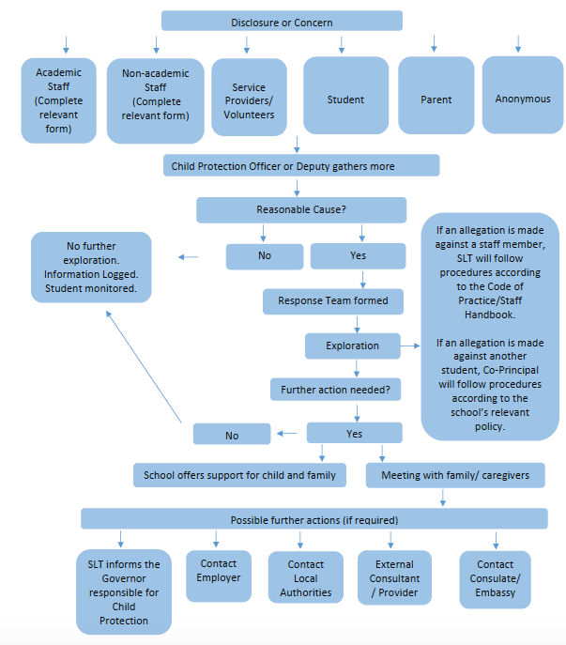

This Policy document will be updated annually in AUGUST to include new post-holders with responsibility for safeguarding
This policy is dated 17th August 2021.

